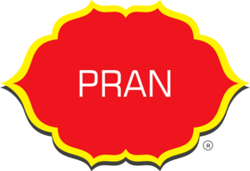
Sanjida Akter Rimu
Batch 41
4 December 2024
A document that provides an overview of my financial company
Table of Contents
1. Executive Summary 2
2. Products and Services 3
2.1 Describing the product and services the PRAN-RFL Group offers : 3
2.2 Hyperlink of the PRAN Company : ( Here) 3
2.3 PRAN Group’s Marketing Cycle: 4
2.4 Some of products of PRAN-RFL Group: 5
3. Business Plan 6
3.1 Business Plan using flow chat : 6
4. Sales and Cost Statistics 7
4.1 Sales and cost statistics of PRAN Group : 7
4.2 Line Chart of Sales and Cost Statistics of PRAN-RFL Group: 7

Executive Summary

PRAN means life, and we stand for the taste of life. Every day we’re sending out this taste to 145 countries with our numerous agro-food products of 10 different categories, including snacks, confectionery, dairy, juices, carbonated beverages, mineral water, baked items, culinary, drinks and biscuits. We’re the largest food-beverage company in Bangladesh and admired by millions of people globally.
Since the beginning of PRAN in 1981, we’ve been working to improve rural livelihood by contributing to the rural and national economies, creating employment and exporting.
PRAN has devoted itself to the betterment of society and environment. That’s why we’re continuously extending our help to the communities and finding ways to reduce our environmental footprints to achieve a greener earth.
PRAN
PRAN is the most versatile and diversified food & beverage Company in Bangladesh We have got a wide range of about 200 brands under its wings. Our dedication and contribution has helped us unlock numerous number of achievements and brought to the table tones of awards. If we continue to receive this uncountable amount of love and support from everyone then it would help us succeed and bring in more awards in nearby future. We take pride in our hard work and continuous efforts that made us become PRAN— a name, a face, an organization of marvelous performance, leaving positive marks on the native, as well as on global grounds in the course.
PRAN is a corporation that firmly believes in providing equal opportunity for everyone, and our talent management has ensured the perfect atmosphere for the workforce, enabling them to work together as a team. Besides, we take every complaint and suggestion with the utmost sincerity to improve the workplace for all. Professional integrity is highly maintained and is, in fact, the core of our work policy.
Above all, as a company, PRAN truly believes in dedicating itself for the benefit of its stakeholders and society at large. We practice the values we uphold and therefore, through our actions, we help the economic progress, and with its growth, the people living inside the economy also advance. Our Vision is to improve livelihood and our mission is “Poverty & hunger are curses”. Our aim is to generate employment and earn dignity & self-respect for our compatriots through profitable enterprises.

Products and Services

Describing the product and services the PRAN-RFL Group offers :

There are numerous products that PRAN-RFL Group offers to its customers:

- Food and beverage: PRAN is Bangladesh's largest food and beverage company, offering products like snacks, dairy, juices, baked goods, and more.
- Plastics: PRAN produces household and industrial plastic products, such as furniture, containers, and pipes.
- Agribusiness: PRAN produces crops, livestock, and fisheries products.
- Home ware: PRAN produces home ware products, such as kitchen appliances, furniture, and electronics.
- Culinary: PRAN offers food products used in cooking, such as spices, condiments, and cooking oils.
- Dairy: PRAN offers dairy products, such as milk, yogurt, and cheese.
- Snacks: PRAN offers snack products, such as potato chips, granola bars, and nuts.
- Confectionery: PRAN offers sweet food products, such as candy, chocolate, and desserts.
- Easy Home Service: RFL Group offers home services, such as product installation and repair, electrical and plumbing services, septic and water tank cleaning, and more.

Hyperlink of the PRAN Company : ( Here)

PRAN Group’s Marketing Cycle:
(Using SmartArt)

Some of products of PRAN-RFL Group:

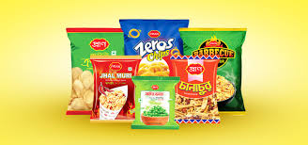 | 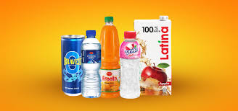
 | 
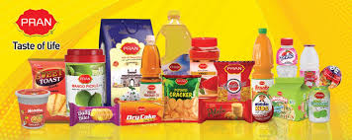

Business Plan

Business Plan using flow chart:

START

Executive Summary
Mission
Vision
Core values
Business overview
Established
Primary business
Target market
Products and services
Market Analysis
Competitive advantage
Customer segmentation
Business objectives
Marketing and scales strategy
Operational planning
Branding
Advertising
Scales channels
Promotion
Financial planning
supply chain
Production
Sustainablity and CSR
Conclusion
Investment
Risk management

Sales and Cost Statistics
Sales and Cost Statistics 0f PRAN-RFL Group in 2022

Revenue | Operating  income | Net  income | Export  goals | Annual  turnover
4690000000 | 359670000 | 83000000 | 2000000000 | 2000000000

Sales and cost statistics of PRAN Group :

Line Chart of Sales and Cost Statistics of PRAN-RFL Group:

